TECHNICAL GUIDE FOR PAPER FORMATTING

TITLE OF THE PAPER

[Times New Roman 13 point, bold, centred, upper case]

**Name of author(s) [Times New Roman, 10 point, bold, centred and Upper and lower case]**

The institution where the author is affiliated [10 point, normal, centred and upper and lower case]

City, Country [10 point, normal, centred and upper and lower case]

*E-mail [10 point, italic, centred and upper and lower case]*

**Abstract**

[Times New Roman 10-point, justified]

The abstract should contain 100 to 200 words.

**Keywords:** [Times New Roman, 10-point, bold, alignment left]

TITLES [Times New Roman, 12- point, bold, upper case and justified]

The paper should be in B5 format (17.6 x 25.1 cm). Margins: top – 2.5 cm; bottom – 2.5 cm; left – 2.5 cm; right – 2.5 cm. The text should be single-spaced in a single column, written in Times New Roman font, 11-point size. The paper should be between 7 to 14 pages in length.

**SUBTITLES [TIMES NEW ROMAN, 11-POINT, NORMAL, ALIGNMENT LEFT]**

IMAGES AND TABLES

Images, tables and graphs should be formatted according to the following instructions:

* All tables and images should be numbered using Arabic numerals;
* Tables and images should always be referenced in the text in numerical order (tables and images should be numbered separately).
* The number of table or image should be in **Bold,** left-aligned, in „Times New Roman“ font, size 10. (For example: **Table #, Image #**)
* Provide a title for each table and image that explains the content.
* Titles should be in *Italics***,** left-aligned, in „Times New Roman“ font size 10, and written in CAPITAL LETTERS.
* Below the table/image, include the *Source* or *Note* (Times New Roman, 10), where the source of the table/image and any additional explanations should be provided.

**Image 1**

*BELEX 15*

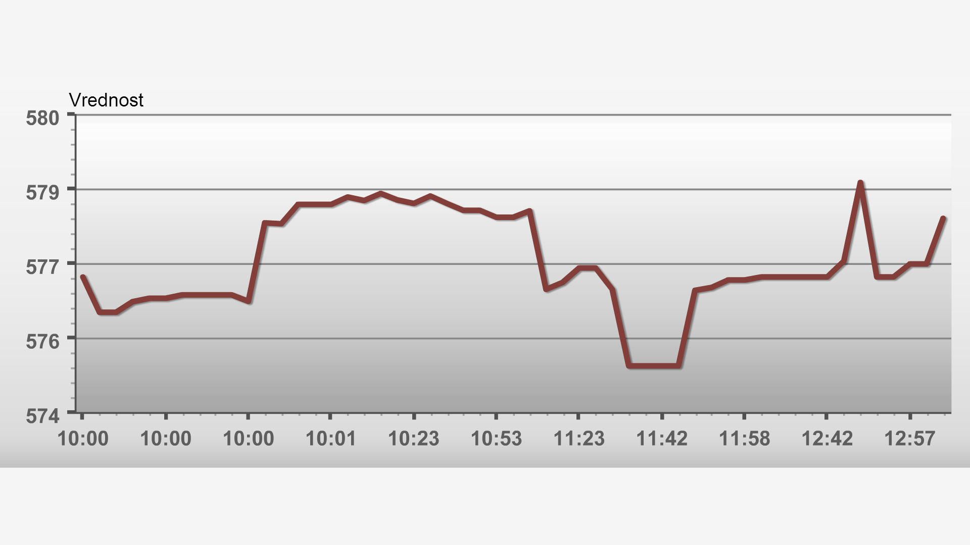

*Source:* <https://www.belex.rs/>

**Table 1**

*VALUES OF PSEUDO-CORRELATION DETERMINATION COEFFICIENTS IN THE ISOLATED MODEL OF PREDICTING PERCEPTION OF FOOTBALL QUALITY*

|  |  |  |  |
| --- | --- | --- | --- |
| Model | -2 Log likelihood | Coxov & Snellov R2 | Nagelkerkeov R2 |
| 1 | 37,039 | 0,071 | 0,129 |

*Source: Redžepagić, B., Plojović, Š., & Ujkanović, E. (2013). Opportunities of transitional potential of BH sports and its more successful connection with the overall tourism offer of Bosnia and Herzegovina.* Economic Challenges*, 2(4), 15-36*. <https://doi.org/10.5937/EkoIzavov1304015R>

CITING SOURCES

In-text source citation is mandatory. Citations in the text should be marked in APA style.

Please do not use footnotes or endnotes for source citation.

1. **In-text citations**
2. **Direct quotes**

* The quoted material should be produced verbatim.
* Always include the author's last name, year of publication, and page number(s).
* If quoting a source without page numbers, cite the paragraph number (e.g., paragraph 4) or other identifying information (e.g., Slide 7, Table 2, Results section).
* You can cite your data as part of a sentence (narrative citation) or at the end in parentheses (parenthetical citation).
* For two or more authors, use 'and' in narrative citations; and '&' in parenthesis.
* For three or more authors, use 'et al.' after the first author's surname indicating additional authors.
* When quoting sources with embedded quotes, include them in the quote, but you don't need to cite embedded quotes on your reference page (only the source you are citing).
* When quoting material with quotes, use double quotes to mark the quote and change the quotes to a single quote..

**Example of a narrative citation**

The general citation style is:

Author (year) "quote" (p. #).

* **Single author:** Meta (2015) says, "each of these funding sources has its own characteristics, advantages, and disadvantages that should be considered when choosing between them" (p. 19)
* **Two authors:** Kalač and Jokić (2017) highlight that “a certain number of the most successful entrepreneurs use part of their achieved financial surpluses for various humanitarian and socially beneficial purposes..." (p. 73).
* **Three or more authors:** Plojović et al. (2022) argue, "Resources (human, material, financial) are needed to achieve the goal. For example, if we talk about software and mention human resources, they are closely related to the complexity of the project" (p. 3).

**Example of a parenthetical citation**

The general citation style is:

"Quote" (Author, year, p. #)

* **Single author:** “each of these funding sources has its own characteristics, advantages, and disadvantages that should be considered when choosing between them.” (Meta, 2015, p. 19)
* **Two authors:** “a certain number of the most successful entrepreneurs use part of their achieved financial surpluses for various humanitarian and socially beneficial purposes…” (Kalač & Jokić, 2017, p. 73).
* **Three or more authors:** “Resources (human, material, financial) are needed to achieve the goal. For example, if we talk about software and mention human resources, they are closely related to the complexity of the project.” (Plojović et al., 2022, p. 3).

1. **Paraphrasing and summarizing**

* Paraphrasing is when you put a passage or idea from another work into your own words.
* A paraphrased passage is generally shorter and more concise than the original.
* You can cite your data as part of the sentence (narrative citation) or at the end in parentheses (parenthetical citation).
* Summarizing is very similar to paraphrasing in that it also involves conveying someone else's ideas in your own words to condense the material.
* A summary includes only the main points and/or ideas of a longer passage or entire work.
* For two authors, use 'and' in narrative citations and the ampersand '&' for parenthetical citations.
* For three or more authors, use 'et al.' after the first author's surname to indicate there are additional authors.
* Include only the author/year from the article you are summarizing. You do not need to include page numbers or section identification.
* If citing multiple works in parentheses, arrange the citations in alphabetical order separated by semicolons.

**Example of narrative paraphrasing**

The general citation style is:

Author (year) summary.

* **Single author:** Meta (2015) emphasizes that investing only makes economic sense if it can achieve effects.
* **Two authors:** Kalač and Jokić (2017) state that the problem does not arise if the lease period is identical or approximately identical to the economic and technological lifespan of the leased item.
* **Three or more authors:** Plojović et al. (2022) emphasize that communication is the way ideas are transmitted from one subject to another.

**Example of parenthetical paraphrasing**

The general citation style is:

Summary (Author, year)

* **Single author:** Investing only makes economic sense if it can achieve effects (Meta, 2015).
* **Two authors:** The problem does not arise if the lease period is identical or approximately identical to the economic and technological lifespan of the leased item (Kalač & Jokić, 2017).
* **Three or more authors:** Communication is the way ideas are transmitted from one subject to another. (Plojović et al., 2022).

1. **Citing in literatura**

A numbered list of sources and literature (formatted in Times New Roman font, 10-point, normal, justified, upper and lower case) should be provided at the end of the paper as follows::

1. **Book (monograph)**

Opšti format je sljedeći:

The general format is: Surname of the author. Initials. (year). *Title of the book* (edition). Publisher.

* **Single author:** Saračević, M. (2012). Tools for Interactive Mathematics Teaching and E-Learning: A Handbook for Mathematics, Informatics, Technical and Informatics Education, Physics, Chemistry Teachers, and Primary School Teachers. University of Novi Pazar.
* **Više autora:** Plojović, Š., Bušatlić, S., & Bećirović, S. (2022). Project Management: (with Examples from the IT Industry). University of Novi Pazar.
* **Translation:** Spic, E. H. (2011). Art and Psyche: A Study on Psychoanalysis and Aesthetics. (A. Nikšić, Trans.). Clio.

1. **Chapter of a book (monograph)**

* **One editor:** Lamotte, J., & Smith, K. (2019). Play therapy. U: V. Carrion (Ed.), *Assessing and treating youth exposed to traumatic stress* (pp. 129-140). American Psychiatric Association.
* **Multiple editors:** Islahi, A. A. (1996). Economic thought of Ibn al-Qayyim. U: Sadeq, A. M. & Ghazali, A. (eds.) *Survey of Islamic Economic Thought* (pp. 300-321). El Kalem.

1. **Scientific paper (article) in a journal**

The general format is as follows:

Author's last name, Initials. (Year). Title of the paper. Title of the Journal, Year (Issue number), pages. DOI.

* **Single autor:** Bećirović, S. (2014). Swedish J.A.K. Bank - an example of an alternative approach in banking.  *Economic challanges*, *3*(6), 71-91. <https://doi.org/10.5937/EkoIzavov1406071B>
* **Multiple authors:** Džemić, K., Bihorac, A., & Fehratović, J. (2022). Totalitarian social system and the thinking individual in contemporary Bosnian-Herzegovinian and Serbian novelistic prose.. *University thought – journal of science, culture and art, Novi Pazar*, *21*, 66-78. <https://doi.org/10.5937/univmis2221066D>

1. **Conference proceedings**

The general format is as follows:

Author’s last name, Initials. (year). Title of the paper. In: *Title of the conference* (pages). Publisher. DOI

* **Single author:** Cvеtkоvić, V. N. (2002). Institutions, state, identity. In: *(Re)construction of institutions: one year of transition in Serbia* (pp. 27-42). Belgrade: Institute for Philosophy and Social Theory.
* **Multiple authors:** Јоvеtić, S. and Јаnkоvić, N. (2011). The importance of scientific-technological development for the socio-economic development of the country: a statistical-econometric model. In: Technology, Culture, and Development: Thematic Collection of Papers from the XVIII International Scientific Conference "Technology, Culture, and Development" (pp. 142-151). "Technology and Society" Association.

1. **Text retrieved from the internet**

The general format is as follows;

Surname of the author, Initials. (Publication date). *Title of the article*. Name of the website. URL.

* **Website with author:** Modestino, A. S. (26.07.2021.). *Diversifying the Dismal Science*. Project Syndicate. <https://www.project-syndicate.org/commentary/tackling-gender-and-racial-discrimination-within-economics-by-alicia-sasser-modestino-2021-07>
* **Institution website:** World Health Organization. (24.04.2019.) *To grow up healthy, children need to sit less and play more*. <https://www.who.int/news-room/detail/24-04-2019-to-grow-up-healthy-children-need-to-sit-less-and-play-more>
* **Website with retrieval date:** Wikipedia (2024). *Scientific Journal.* Retrieved 14.02.2024. from <https://sr.wikipedia.org/wiki/Nau%C4%8Dni_%C4%8Dasopis>

Note: The retrieval date is not generally necessary, except for encyclopedic entries where page content can change.

PAGE NUMBERS AND HEADERS

Please do not use page numbers or headers.

SUMMARY

At the end of the text, it is necessary to provide a summary of the article in English, up to one page in length, if the paper is not in English.